Shopify Challenge 2021 – Noah Lim

If you were to open a Shopify store, what would you sell and why?
Firstly, I have created a handful of Shopify stores after learning about the Drop-Shipping business model back in high school (2016-2020). I think my first store was a jewelry store I created during the pandemic aimed at selling various pieces of jewelry made of different artistical mediums. My second store was a fitness inspired store in which I sold many fitness related items. I had one product I was confident about and decided to advertise it using the Facebook ads platform. It was a cool product, essentially it was a portable blender that could fit in a cup holder. As I learned the Facebook advertising algorithm my traffic to the store grew close to 100 visitors a day. Here’s a screen shot of the traffic and the product. During my time working on the stores I learned so much about Shopify as a company and their platform. Now over one year later, heading into my second year of college, studying software development. I can provide a use to this company that I am passionate about and have experience on their platform.
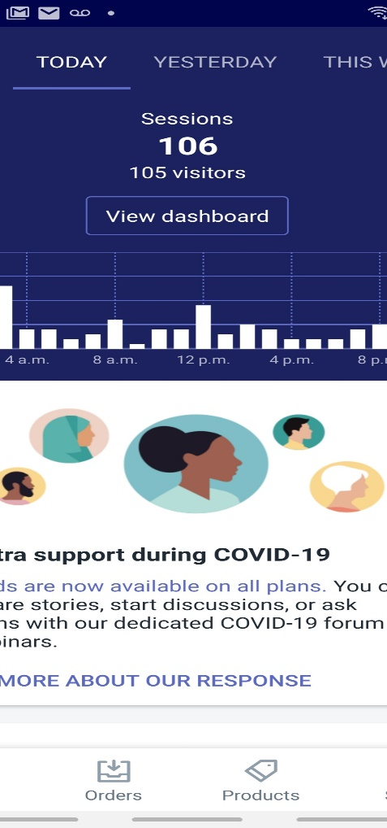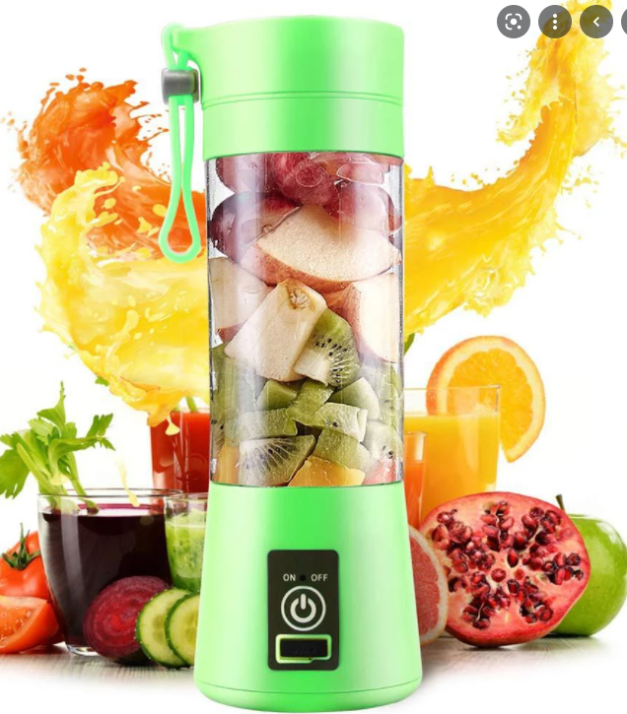

Any last thoughts?
In my spare time apart from schoolwork and software development I actually like to 3D print!
I am very knowledgeable in 3D printing and started in grade 9, so I do have 5 years of 3D printing experience. Aside from 3D printing I like to listen to music and play video games frequently. Furthermore, one cool achievement in my software development journey would have to be creating a Blazor application while doing an summer internship for my dad which was essentially a chatroom. I used signal R client so that the user could chat with another user running the same app on another server. The frontend was bootstrap and the backend was C# and ASP.NET.

